Title
Design of IOT Architecture of Battery Charging Management Technology.
Abstract
The rapid growth of electric vehicles (EVs) has led to an increasing demand for efficient charging infrastructure. This project proposes an Internet of Things (IoT) architecture for battery charging management, integrating renewable energy sources such as solar power and energy storage systems (ESS) with grid power. The architecture comprises five layers: User Interface Application Layer, Cloud Server and Data Storage, Communication Layer, Microcontroller and Data Acquisition Layer, and Sensor Layer. By utilizing real-time data monitoring and predictive analytics, this system aims to optimize power demand, enhance battery management, and improve overall efficiency in EV charging operations. Preliminary simulations indicate a significant reduction in operational costs, achieving 90% cost efficiency through optimized resource utilization.

Introduction
As electric vehicles become increasingly prevalent in the transportation sector, the need for robust charging infrastructure has intensified. The integration of various power generation sources—specifically solar energy, energy storage systems (ESS), and grid power—presents a sustainable solution to meet the growing energy demands of EV charging stations. This project focuses on developing an IoT-based architecture that facilitates efficient battery charging management by leveraging real-time data analytics and centralized monitoring.
The proposed IoT architecture consists of five distinct layers:
- User Interface Application Layer
- Cloud Server and Data Storage
- Communication Layer
- Microcontroller Layer
- Sensor Layer

Research Gap
Lack of uniform standards for EV charging stations, leading to compatibility issues.
Limited studies on optimizing the mix of renewable energy sources for charging stations.
Insufficient research on the challenges and economic viability of vehicle-to-grid technology.
Need for more research on consumer behavior and preferences regarding EV charging.
Emerging field with limited studies on how IoT can enhance charging infrastructure efficiency.

Market Demand
Rapid increase in electric vehicle sales necessitates more charging stations.
Policies and subsidies promoting EV adoption boost infrastructure demand.
Innovations in fast and smart charging systems enhance convenience and demand.
Growing consumer preference for renewable energy-powered charging solutions.
Smart city initiatives are increasing investments in connected EV charging infrastructure.
Expanding accessible charging networks is crucial to alleviating consumer concerns about running out of power.

Proposed Methodology
The proposed methodology for developing an IoT architecture for battery charging management focuses on integrating various components to optimize electric vehicle (EV) charging infrastructure. It begins with designing a layered architecture that includes a User Interface Application Layer for mobile and web access, a Cloud Server for data storage and analytics, and a Communication Layer with IoT gateways for device connectivity. The Microcontroller Layer will use Battery Management Systems (BMS) to process real-time data from sensors deployed in the Sensor Layer, which will monitor key parameters like voltage, temperature, and state-of-charge (SOC) of batteries.
The Data will be collected through IoT devices and sent to the cloud for analysis. The system will integrate multiple energy sources—solar power, Energy Storage Systems (ESS), and grid power—at the Point of Common Coupling (PCC), prioritizing solar energy first, then ESS, and using grid power as a backup. Real-time monitoring will allow users to track charging status and energy consumption, while cloud analytics will help predict power demand and optimize charging schedules.
This methodology aims to create an effective IoT architecture that enhances battery charging management and improves user experience.

Simulation design
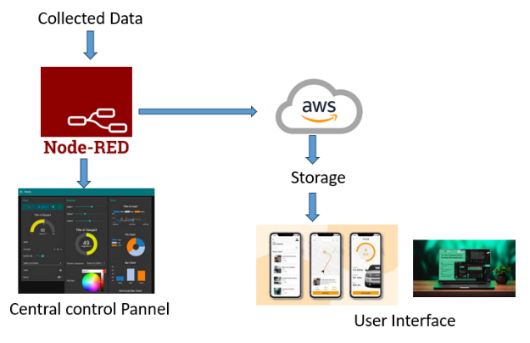
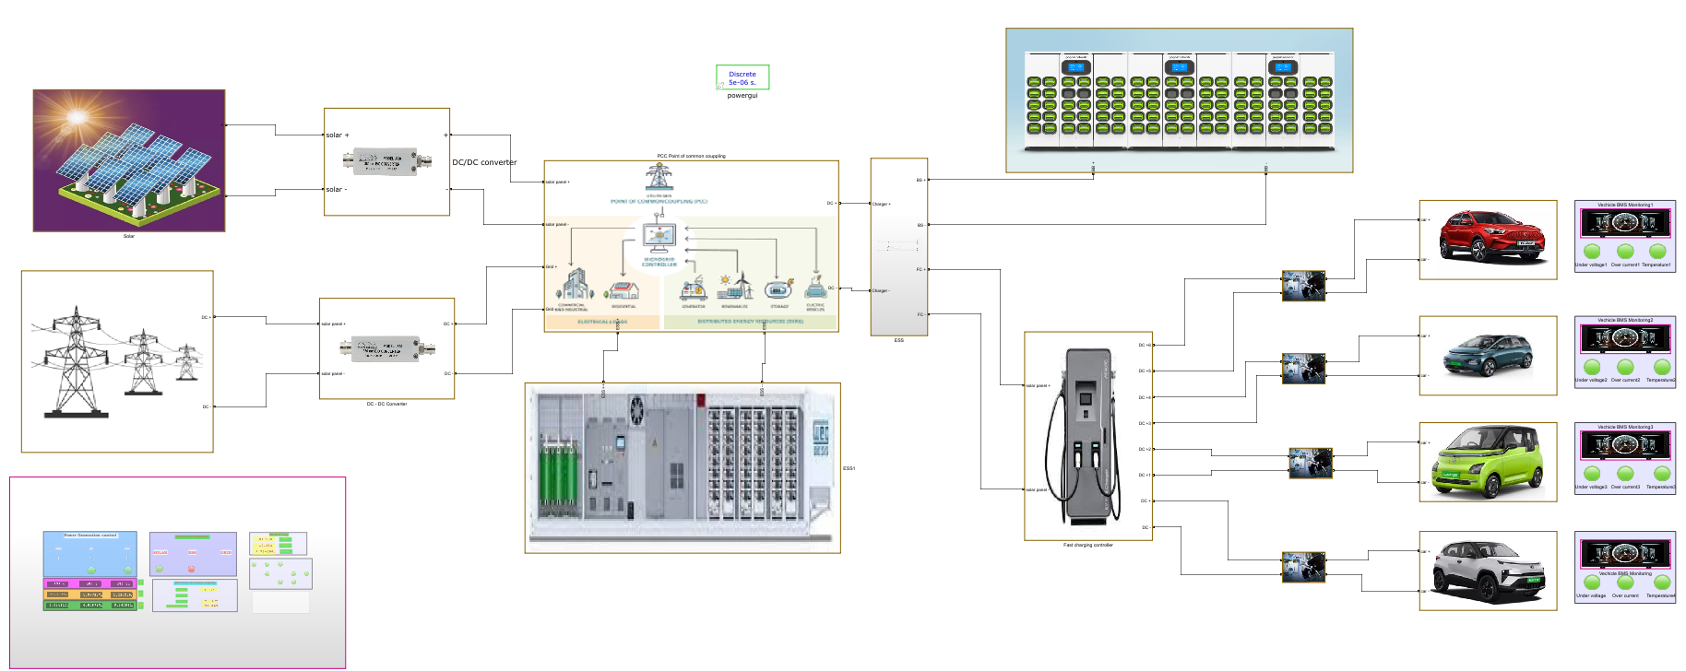
Future Scope:
- Optimize operations to significantly lower operational costs by monitoring energy consumption and automating maintenance schedules, preventing costly downtimes.
- Enables real-time data collection and analysis to streamline processes, improve productivity, and allow for proactive maintenance, minimizing disruptions.
- Provides customers with real-time information on product availability and personalized recommendations, enhancing engagement and satisfaction, which leads to increased loyalty.
- Facilitates the collection of valuable data on customer behavior and operational performance, allowing businesses to identify trends and make informed decisions for growth.
- The scalable IoT architecture allows businesses to expand their charging infrastructure as demand increases, enabling quick adaptation to changing market conditions and consumer needs.

Conclusion
The proposed IoT architecture for battery charging management not only addresses the immediate challenges posed by the growing demand for EV charging stations but also promotes sustainable practices through the utilization of renewable energy sources. By implementing real-time monitoring and predictive analytics, this system enhances operational efficiency, reduces costs, and contributes to a greener transportation ecosystem. Future work will focus on refining the architecture and expanding its capabilities to further optimize energy management in electric vehicle applications.

